**Software Design - HW2**

**Group 2**

**GitHub:** [**github.com/yoshadmun/VolunteerActivities**](http://github.com/yoshadmun/VolunteerActivities)

**Design and Development Methodology:**

Our methodology for this assignment has remained Agile Development.

* Component-Based Architecture: Our project utilizes a component-based architecture typical in React applications. This approach promotes reusability, maintainability, and modularity. Each page is encapsulated within its own component, such as Login, AdminDashboard, and EventForm.
* Routing: We used React Router for client-side routing. This maps different URL paths to specific components, and allows seamless transitions between pages.
* Global Styling: CSS rules in the index.css file defines global styles for HTML and body elements. This allows consistent styling across the application.
* Additional “user experience” considerations: We created additional pages such as Home page and Admin Dashboard with clear navigation links in order to improve the user flow.

Ultimately, our plan to use React for the front-end with .jsx syntax was the approach we took. This allowed us to write HTML-like code within JavaScript and helped us greatly in maintaining consistency across our codebases.

**Front-End Technologies and Responsibilities:**

* JavaScript: The programming language we used to create interactive components and manage application logic.
* React: This is the JavaScript library we used for building user interfaces. This also allowed us to use React Router for handling navigation between different components.
* CSS: This was used for styling the application.
* HTML: This is the language we used within React components to structure the user interface.
* Node.js: We used Node.js for the development environment, package management, and running build scripts.

| **Group Member Name** | **What is your contribution?** |  |
| --- | --- | --- |
| Matin Amoozadeh | Login Page, User Registration, and User Profile Management. |  |
| Thinh Pham | Event Management, Volunteer Matching Form, and implemented React routing system. |  |
| Shadmun Talukder Shahed | Notification System, Volunteer History, and wrote the documentation. |  |

Aside from individual contributions. We had one in-person and two online team meetings, and this allowed us to collaboratively decide on the CSS global styling which allowed for consistent styling in-between pages.

**Screenshots of our Front-End website:**

1. Home Page:

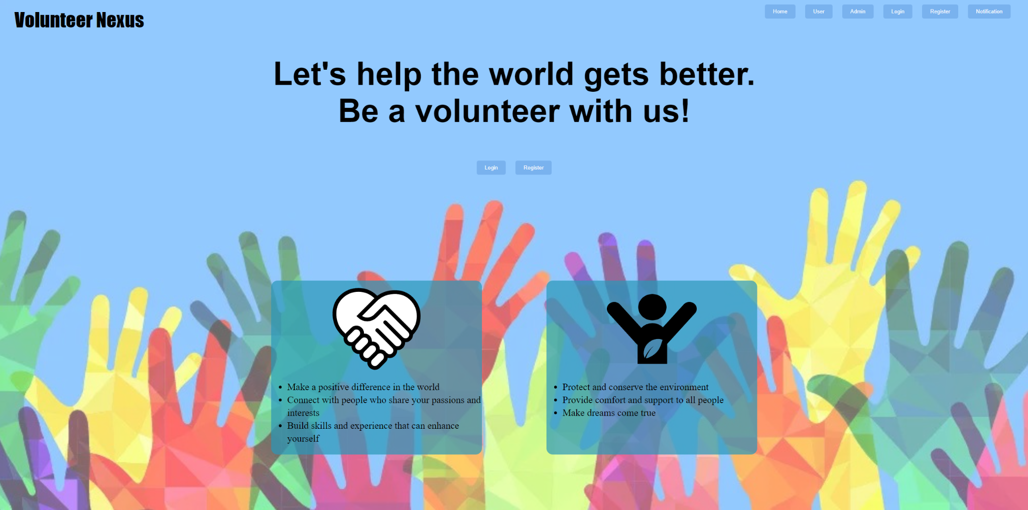

1. Login Page:

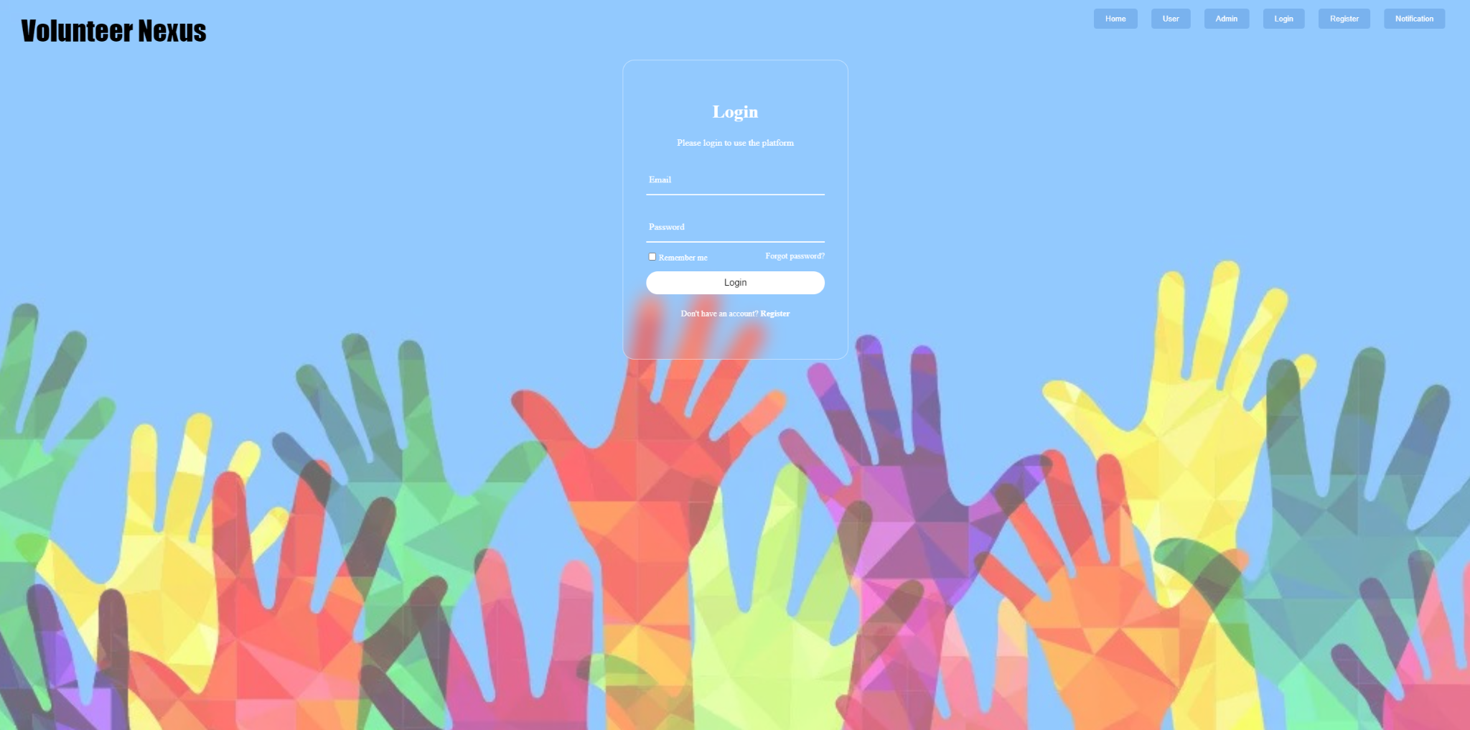

1. User Registration:

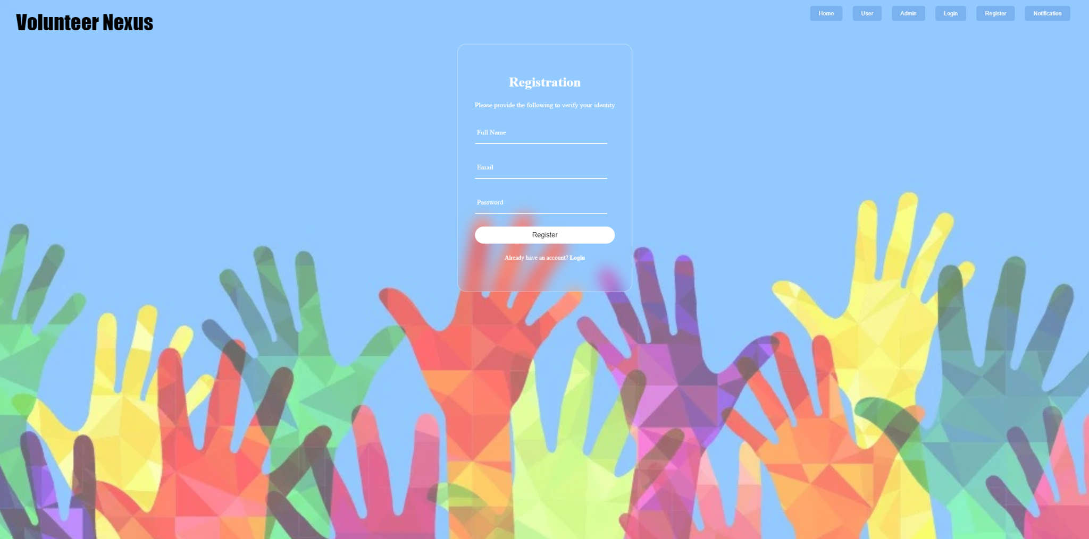

1. Administrator Dashboard:

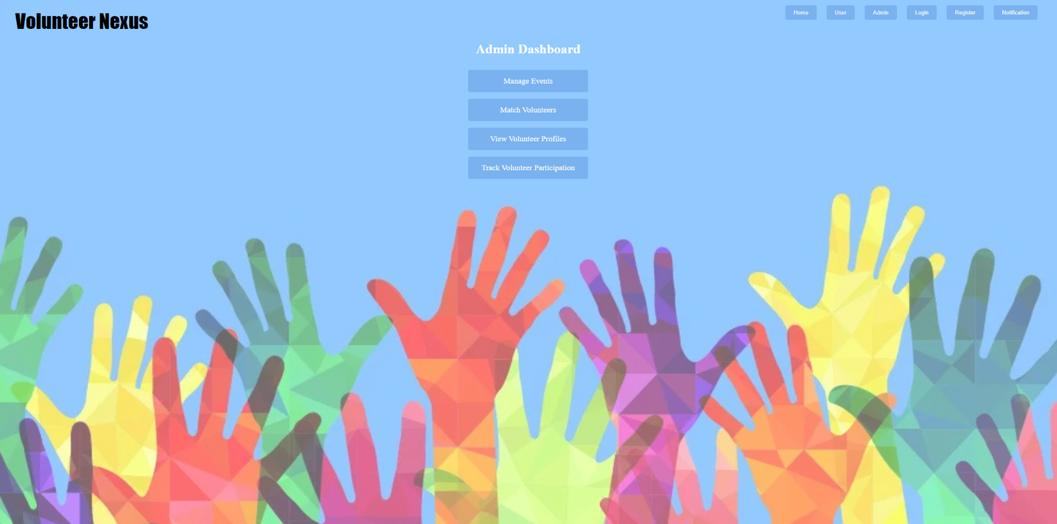

1. User Dashboard:

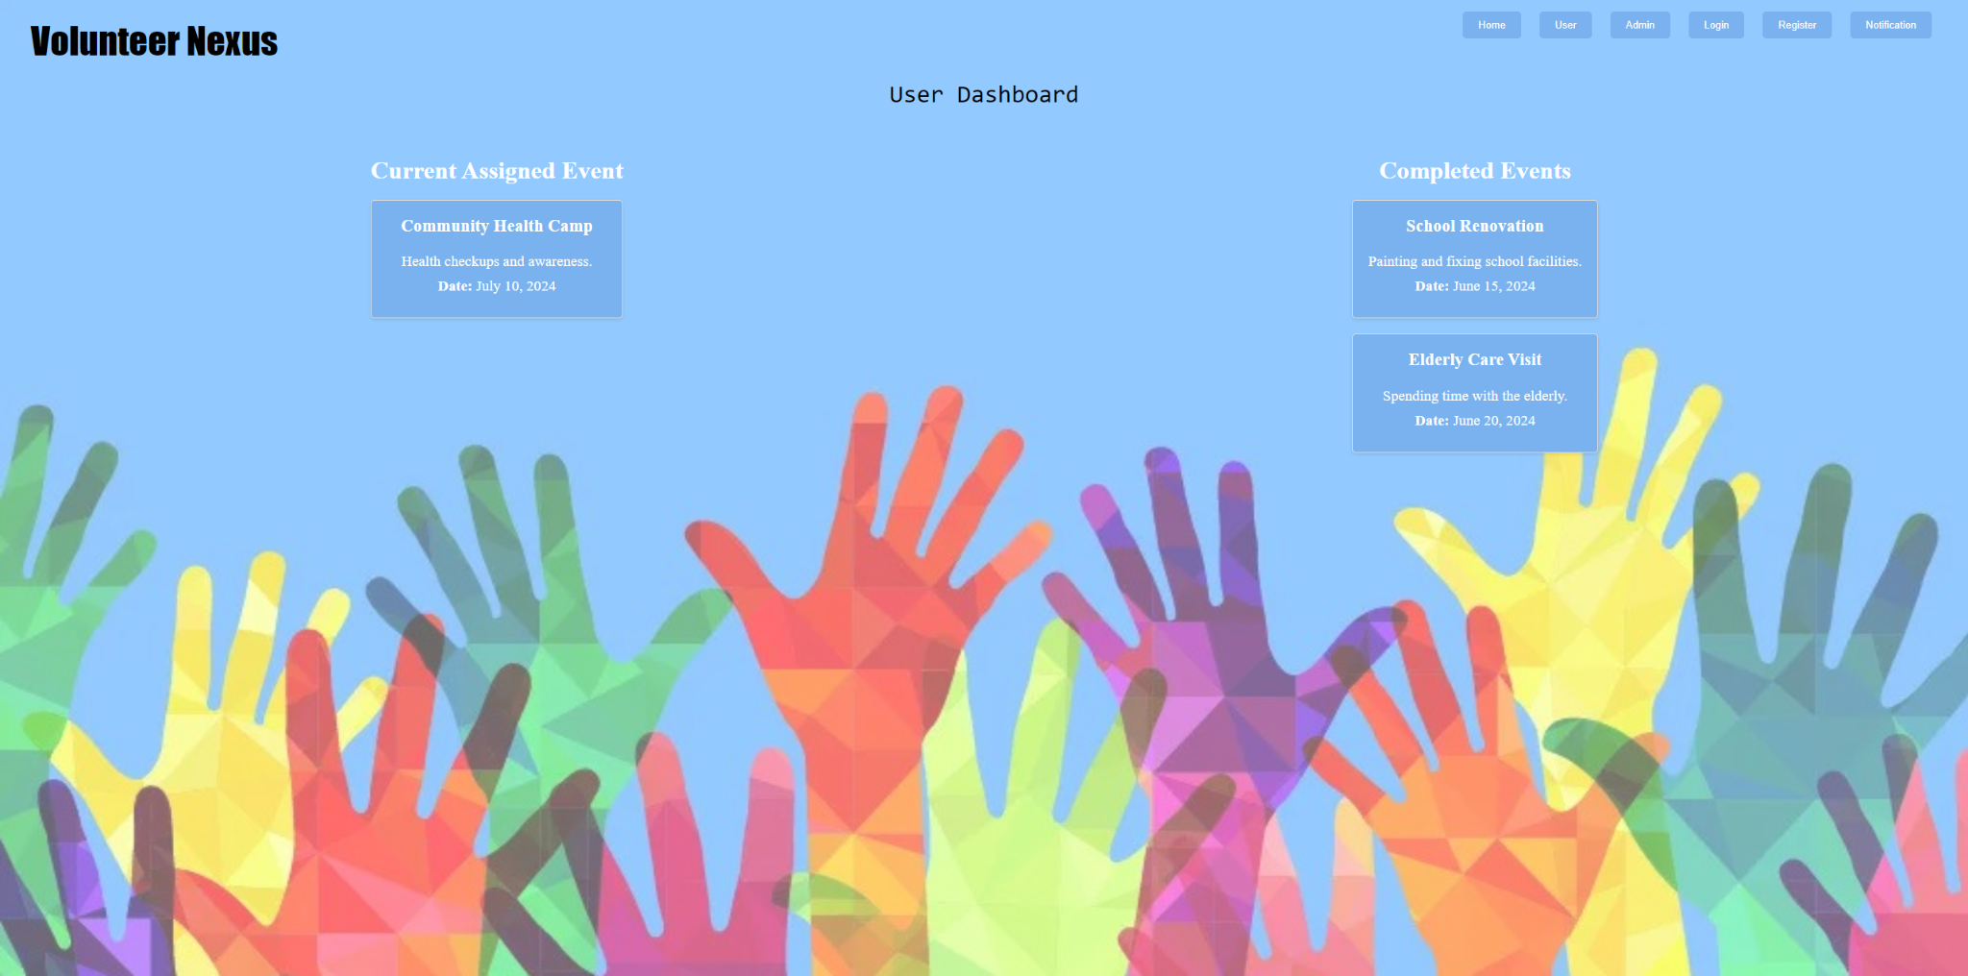

1. Event Management Form:

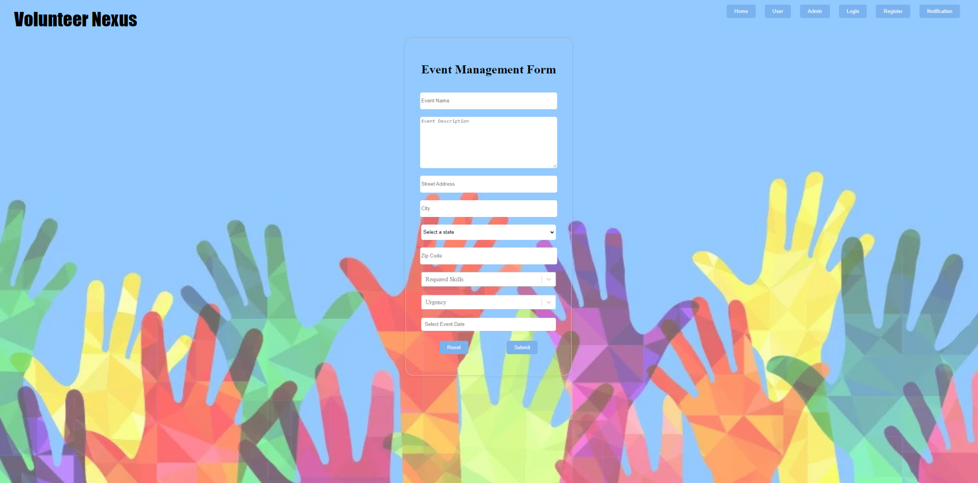

1. Volunteer Matching Form:

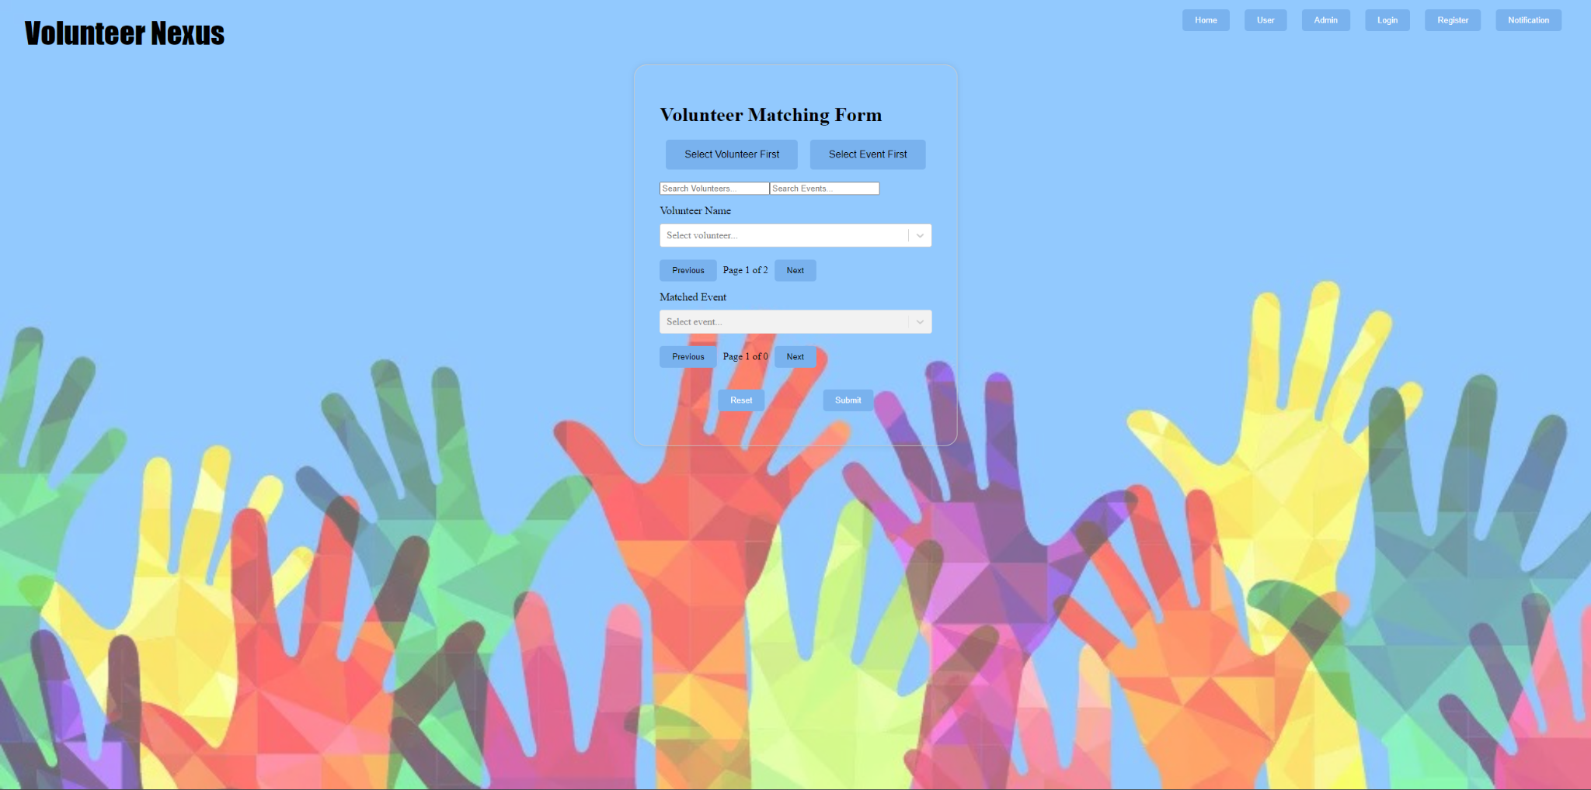

1. User Profile Form:

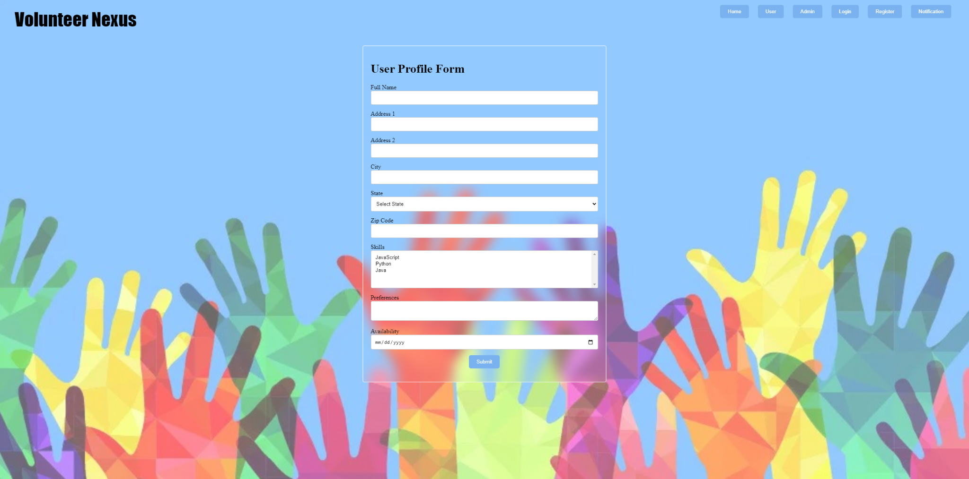

1. View Volunteer Profiles:

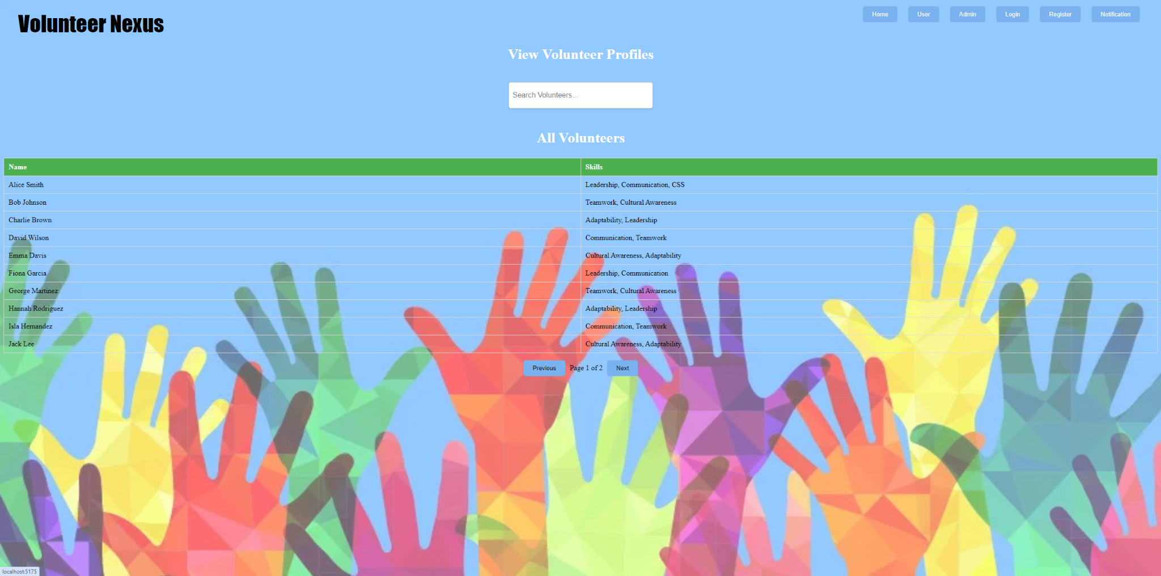

1. Volunteer History:

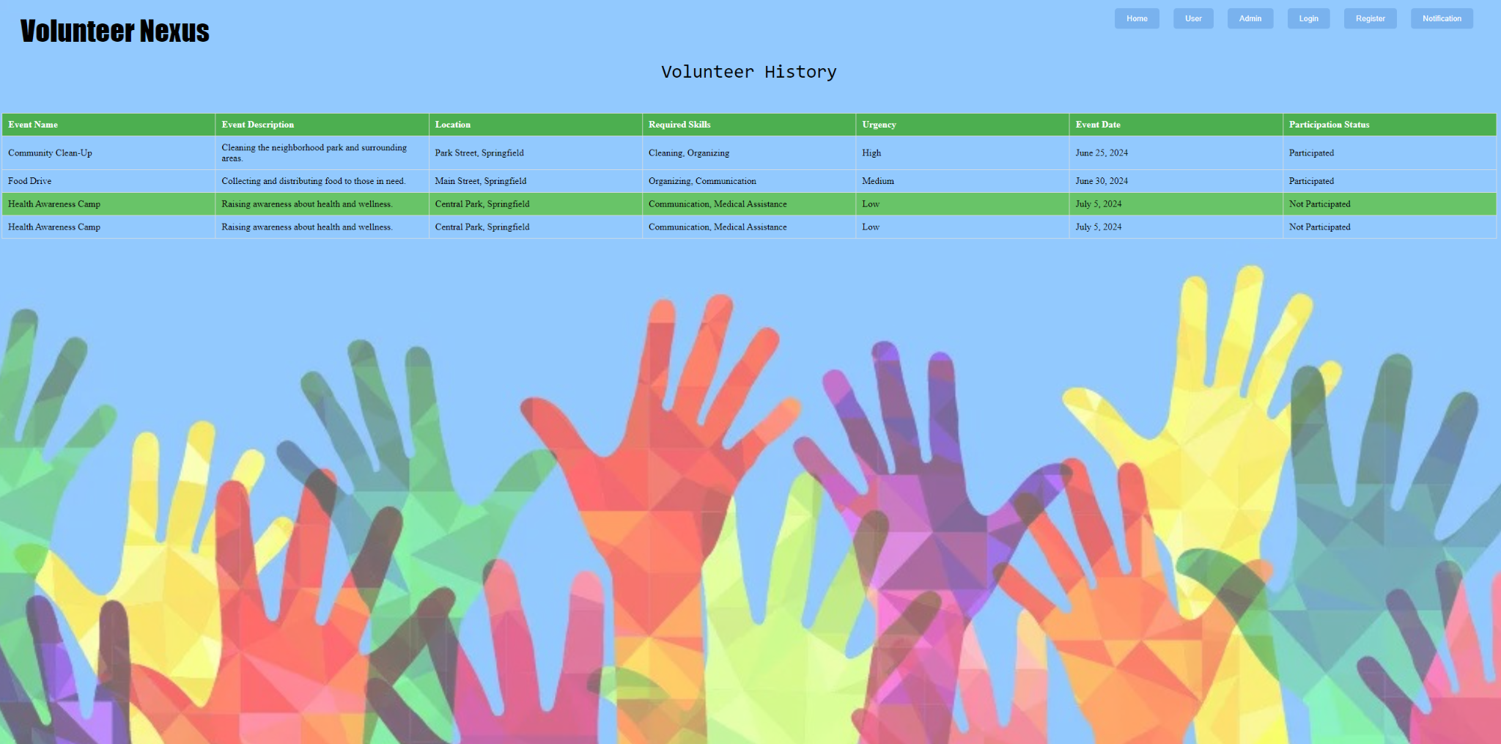

1. Notification System:

